**Computational Mathematics Final Term Project**

|  |  |  |
| --- | --- | --- |
| Group 6 | | |
| ID | Name | 分工 |
| 102062514 | 朱財德 | 25% |
| 102062537 | 郭炳成 | 25% |
| 102062548 | 詹育陞 | 25% |
| 102062617 | 廖楚喬 | 25% |

1. **“8OX” data set**

(a) covariance matrix

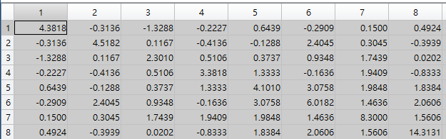

(b). Eigenvalues (in descending order)



(c). percentage of lambda (%)



|  |  |
| --- | --- |
|  |  |
| (d).PCA(first 2 principal components) | (e).PCA(first 3 principal components) |
|  |  |
| (f).LDA  (the most 2 discriminative features) | (g).LDA  (the most 3 discriminative features) |
|  | |
| (f). Dendrogram of 8OX dataset | |

2. **G19 data set**

(a) covariance matrix

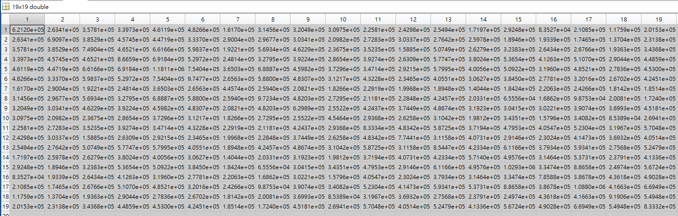

(b). Eigenvalues (in descending order)

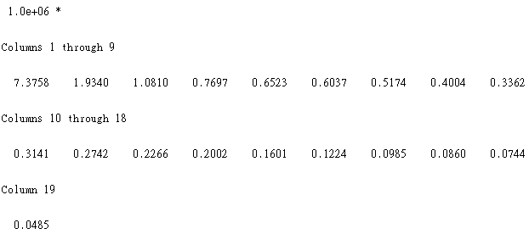

(c). percentage of lambda (%)

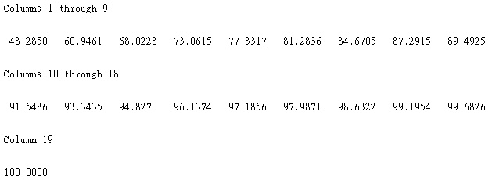

|  |  |
| --- | --- |
|  |  |
| (d).PCA(first 2 principal components) | (e).PCA(first 3 principal components) |
|  |  |
| (f).LDA  (the most 2 discriminative features) | (g).LDA  (the most 3 discriminative features) |
|  | |
| (f). Dendrogram of G19 dataset | |

3. For the data set “**IMOX**.txt” introduced in class, there are *n* = 192 patterns from *k* = 4 categories, each pattern consists of *d* = 8 features. Repeat the same processes as required in problem (1).

(a). covariance matrix

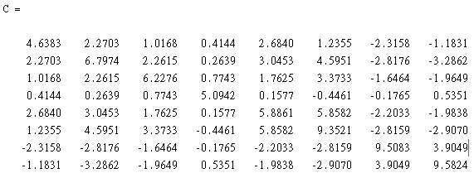

(b). Eigenvalues (in descending order)



(c). percentage of lambda (%)



|  |  |
| --- | --- |
|  |  |
| (d).PCA(first 2 principal components) | (e).PCA(first 3 principal components) |
|  |  |
| (f).LDA  (the most 2 discriminative features) | (g).LDA  (the most 3 discriminative features) |
|  | |
| (f). Dendrogram of IMOX dataset | |

4. **Iris data set**

(a) covariance matrix

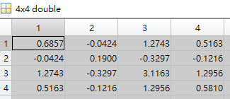

(b). Eigenvalues (in descending order)



(c). percentage of lambda (%)



|  |  |
| --- | --- |
|  |  |
| (d).PCA(first 2 principal components) | (e).PCA(first 3 principal components) |
|  |  |
| (f).LDA  (the most 2 discriminative features) | (g).LDA  (the most 3 discriminative features) |
|  | |
| (f). Dendrogram of IRIS dataset | |